NATIONAL UNIVERSITY OF SCIENCES & TECHNOLOGY


Degree: MS-Bioinformatics
Department: School of Interdisciplinary Engineering & Sciences (SINES)
Submitted to: Dr. Ishrat Jabeen
Project No: 01

Student name: Mahreen Nawaz
Registration No. 533241
Subject: Molecular modelling and drug design
Topic: Homology Modelling
Submission Date: 21st February 2025

Table of figures

Figure 1: Identification of target protein, fig (A) is NCBI Blast search using non redundant database, fig (B) is uniport search result. 3
Figure 2: Template search, fig (A) shows NCBI blast result using PSI blast and PDB database, fig (B) shows PDB search results. 4
Figure 3: Snapshot PIR file of target protein. 5
Figure 4: Ramachandran plot with its statistics. 6
Figure 5: 3D Structure of target protein model the red color shows coil while cyan color shows Helices. 7

- Identify the target protein. Provide name of the protein and provide name of the protein family.
The target protein is serotonin transporter (SERT or HTT) also known as sodium dependent serotonin transporter and solute carrier family 6 member 4. It is encoded by gene SLC6A4 gene. This protein belongs to monoamine transporter (MATs). These proteins are present in plasma membrane and have three major classes of proteins:
- Serotonin Transporter
- Dopamine Transporter
- Norepinephrine Transporter
SERT transport neurotransmitter serotonin from synaptic cleft back to the presynaptic neuron in a process known as serotonin reuptake. This transport of serotonin by the SERT protein terminates the action of serotonin and recycles it in a sodium-dependent manner.
- Provide the accession number of the protein to which the target sequence belongs.
Accession Number: EAW51223
- What is this protein family in general and target protein in particular?
Protein Name: Serotonin transporter/solute carrier family 6 member 4
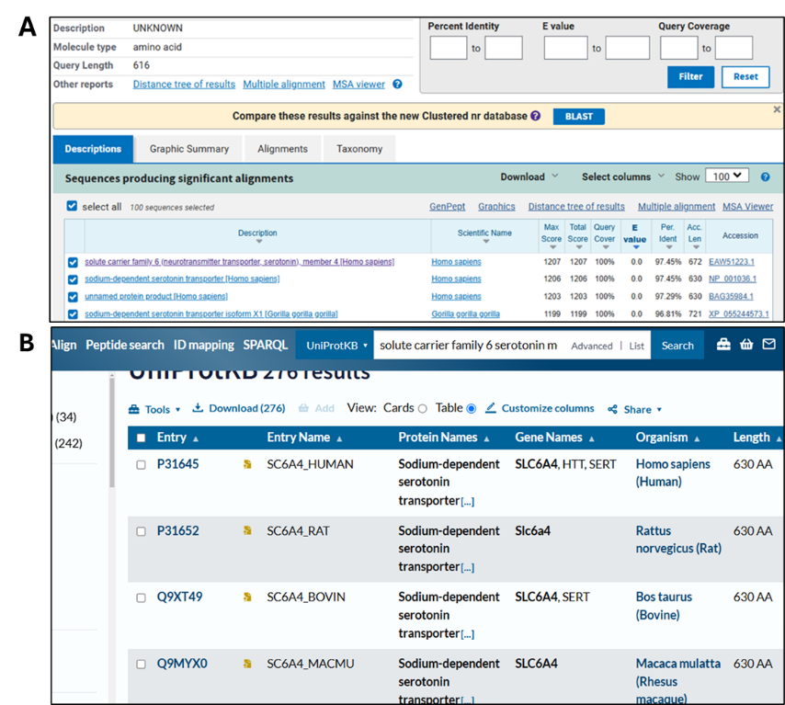
Protein Family : Monoamine transporters (MATs).
Figure 1: Identification of target protein, fig (A) is NCBI Blast search using non redundant database, fig (B) is uniport search result.

- Take a screenshot of the BLAST results and add a screenshot to this file.
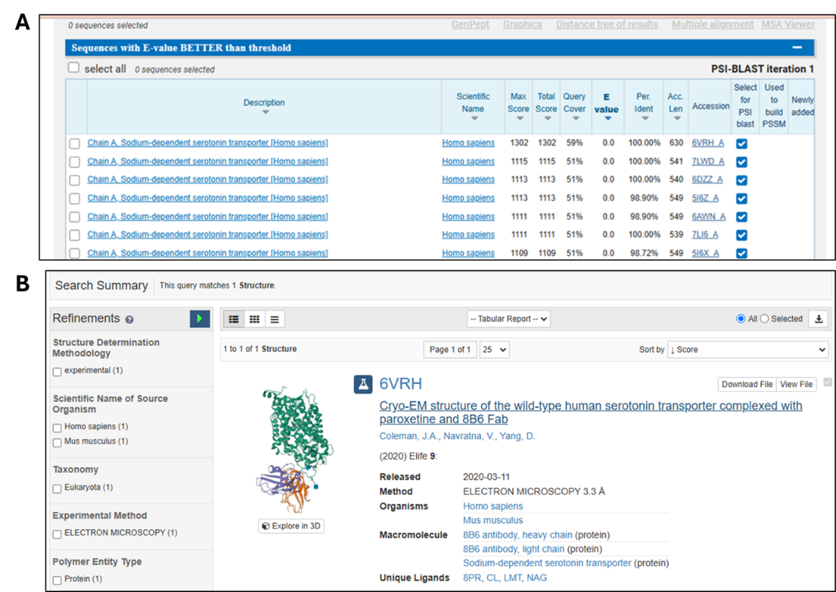
Figure 2: Template search, fig (A) shows NCBI blast result using PSI blast and PDB database, fig (B) shows PDB search results.
Explanation of the PSI-blast result columns of NCBI:
Max Score: The highest individual alignment score (bit-score) for a segment of the query sequence aligned to the subject sequence.
Total Score: The sum of scores for all aligned segments in a sequence. Higher scores indicate stronger similarity.
Query cover: The percentage of the query sequence that is aligned to the subject sequence, higher value means the query matches the database sequence.
E: value: The probability of obtaining a match by chance. A lower E-value (closer to 0) indicates a more significant alignment.
Per. Ident: (Percentage Identity): The percentage of identical residues between the query and the subject sequence in the aligned region.
Acc. Len (Accession Length): The length of the matched sequence in the database.
- Why did you select this template and not the others? You should be able to justify your choices by logical arguments.
I selected the protein 6VRH_A as a template to be used in this homology modelling project because of 100% query coverage, 100% identity, higher Max Score, Total score and lower E-value (Expectation value).
- Highlight the conserved regions, identify the gaps and paste a snapshot of the aligned sequences in your assignment.
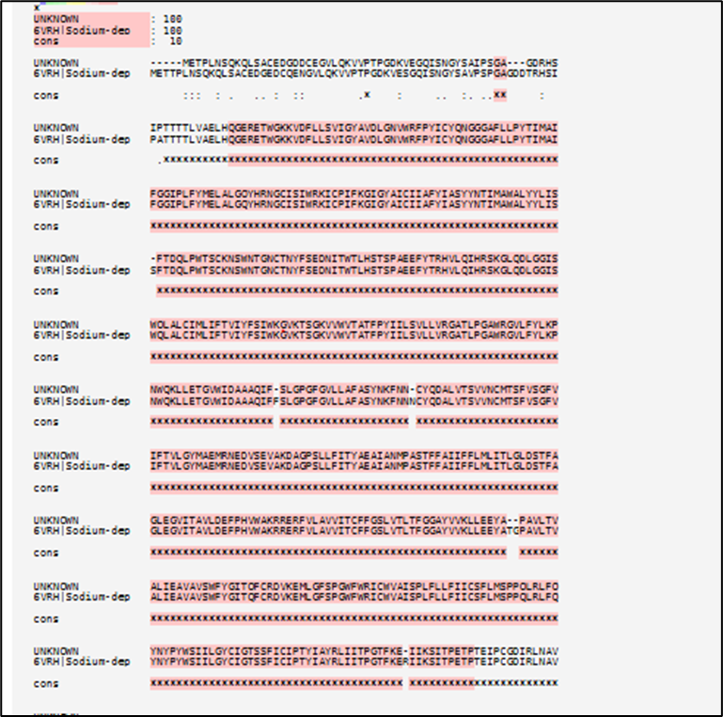
Figure 3: Alignment results of TCOFFEE with highlighted conserved regions with asterisk* representing fully conserved regions, with dot (.) representing weekly similar residues.
- Why did we do a structural alignment instead of a regular alignment?
Structural alignment is performed instead of regular (sequence-based) alignment when the goal is to compare the 3D conformations of proteins rather than just their amino acid sequences. Structural alignment is a valuable tool for the comparison of proteins with low sequence similarity, where evolutionary relationships between proteins cannot be easily detected by standard sequence alignment techniques. Structural alignment can therefore be used to imply evolutionary relationships between proteins that share very little common sequence.
- Take a snapshot and paste in the file. What information does the header of PIR format provide?
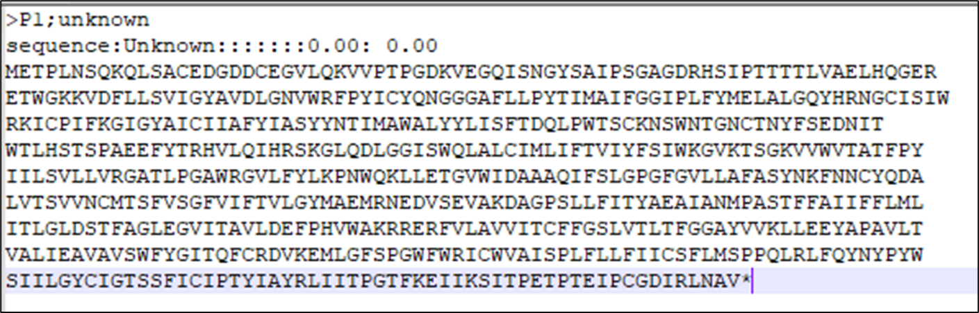
Figure 4: Snapshot PIR file of target protein.
PIR header explanation:
The PIR (Protein Information Resource) format is a file format used to represent protein and nucleic acid sequences. It is commonly used in multiple sequence alignments, structural analysis, and homology modeling tools such as MODELLER.
Structure of PIR Format
A PIR file consists of two header lines followed by the sequence data.
First Header Line:
(>P1;unknown)
Begins with >P1; to indicate PIR format.
Sequence name is a unique identifier for the sequence.
Second Header Line (sequence description)
Provides additional information about the sequence.
Contains metadata such as function, structure classification, taxonomy, or alignment score.
Fields are separated by colons (:) and include:
sequence type (sequence for proteins or nucleotides).
description (optional).
scoring information (optional, used in some tools).
3. Sequence Data:
The sequence is written in single-letter amino acid or nucleotide codes.
Line breaks are allowed for readability.
Ends with an asterisk (*), which indicates the termination of the sequence.
- Provide the Ramachandran plots statistics (i.e., residues in the favorable, generously allowed and not-allowed regions).
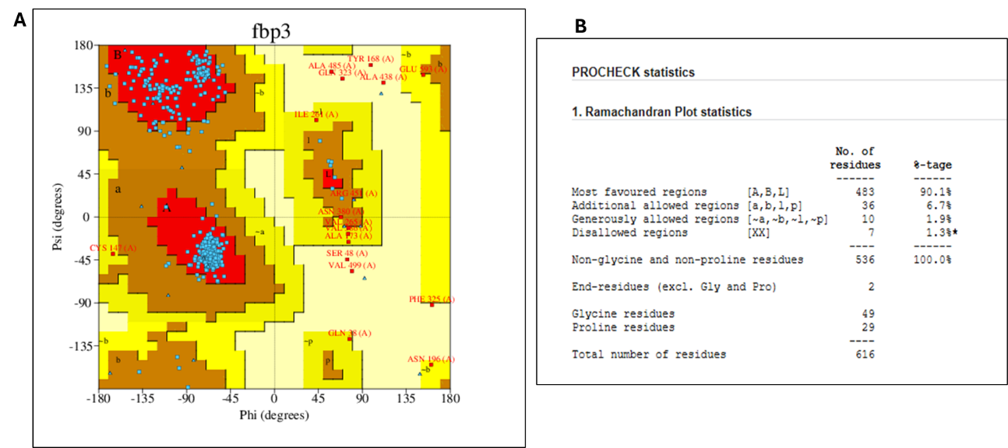
Figure 5: Ramachandran plot with its statistics.
- Are there any residues in the outlier region?
Yes, there are residues in the outlier (disallowed) region.
From the Ramachandran Plot statistics, the disallowed regions contain 7 residues, which account for 1.3% of the total residues. These residues are considered outliers because their phi (ϕ) and psi (ψ) angles do not fall within the commonly allowed regions.
- Provide the ERRAT score value for the target sequence.
ERRAT score: 55.91
- Looking at the 3D structure of the structure, identify the number of helices and beta sheets.
Looking at the 3d there is only one helices and no beta sheet in the structure as showed in the Fig 5.
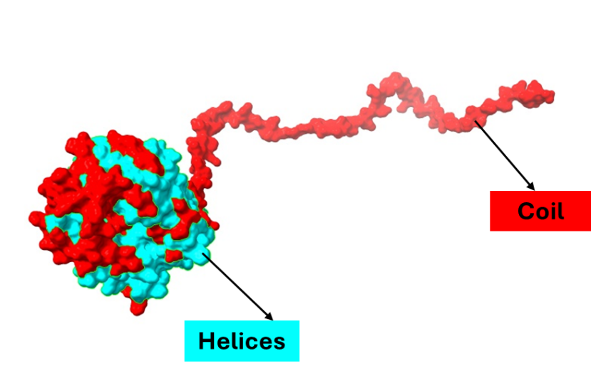
Figure 6: 3D Structure of target protein model the red color shows coil while cyan color shows Helices.
- Describe the normal physiological role of the identified protein along with its malfunctioning in disease condition.
The solute carrier family 6 member 4 (SLC6A4), also known as the serotonin transporter (SERT), plays a crucial role in regulating serotonin (5-hydroxytryptamine, 5-HT) levels in the nervous system.
Normal Physiological Role:
Serotonin Reuptake:
SLC6A4 is responsible for the reuptake of serotonin from the synaptic cleft into presynaptic neurons, terminating serotonergic signaling. This process ensures proper neurotransmission and maintains serotonin homeostasis.
Neurotransmission Regulation:
By controlling serotonin availability, SLC6A4 affects mood, cognition, appetite, and sleep regulation. It is a key player in emotional and behavioral responses.
Gastrointestinal Function:
SLC6A4 is expressed in enteric neurons and intestinal epithelium, where it regulates serotonin uptake in the gut, influencing motility and secretion.
Platelet Function:
SLC6A4 transports serotonin into platelets, where it is stored and later released during clot formation, contributing to vascular homeostasis.
Malfunctioning in Disease Conditions:
Depression and Anxiety Disorders:
Dysregulation of SLC6A4 leads to altered serotonin levels, contributing to mood disorders. Polymorphisms in the SLC6A4 gene (e.g., 5-HTTLPR) have been linked to an increased risk of depression and anxiety.
Obsessive-Compulsive Disorder (OCD):
Reduced serotonin reuptake due to mutations in SLC6A4 is associated with compulsive behaviors and intrusive thoughts.
Autism Spectrum Disorder (ASD):
Altered serotonin transporter function has been implicated in ASD, affecting social behavior, cognition, and sensory processing.
Irritable Bowel Syndrome (IBS):
Dysfunctional serotonin reuptake in the gut leads to abnormal motility and visceral hypersensitivity, contributing to IBS symptoms.
Cardiovascular Diseases:
Changes in serotonin uptake by platelets can influence blood pressure regulation and clot formation, contributing to hypertension and cardiovascular risk.

Summary of all the models:
Model | ERRAT value | No of amino acids in allowed regions. | No of amino acids in disallowed regions.
1 (Mahreen) | 55.91 | 90.1 | 1.3
2 (Aisha Arshad)
3 (Inshal)
4 (Haniya)
5 (Siraj)

